Springboro Strings Concert uniforms
Dear Parents,
For the 2016-17 school year and beyond, we are going to have students purchase their concert attire from a single common source so that we all match (color, fabric and length) and look much more polished up on stage. Students are permitted to choose any top/bottom combo from the items listed below. Girls may opt to wear a dress, the top/skirt combo, the top/bottom combo, or even wear the button down dress shirt and Boro tie. Guys will be asked to buy the button down shirt and dress pants (if you don’t already have something exactly like this.) All students are expected to wear BLACK socks and black/dark dress shoes.

The vendor we are selecting specializes in group concert attire and will never run out of stock, and carries the same styles for many years; I do not plan on changing our attire selections anytime in the next ten years. We are having students purchase their own attire so they may keep it, rather than keeping an inventory at school for lending-out (which requires significant parent volunteer time and yearly dry cleaning bills, not to mention a ton of money upfront to buy enough of every size needed). Students are expected to have their uniform ready to wear well before our first concert day in the fall, October 6, 2016. Plan ahead for shipping times and if you buy the dress or skirt, it will likely need hemming.

If your student out-grows their outfit and would like to re-sell it to an incoming Freshmen, that is an option we can share in the future years. However, for this upcoming year, please reserve around $75 (this includes shipping costs) for their concert attire. If you are in financial need, please contact me separately and SOA may be able to establish a uniform scholarship fund.

Imbedded below are links to each item. The main website is www.concertattire.com Please pay specific attention to the product names, styles and colors specified when ordering.

Students may choose from the following options (must pick one top and one bottom):
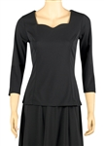Kaylee 3/4 Sleeve Sweetheart Neckline Blouse
Style #2206
Our Price: $30.00
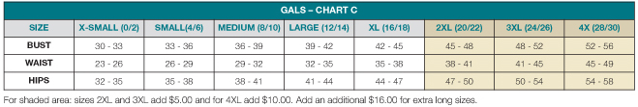

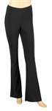Faith Bootleg Pants
Style #1122
Our Price: $31.00
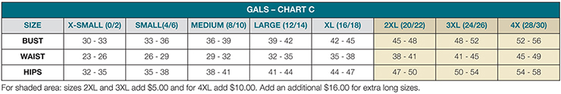
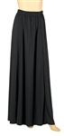Tatiana Floor Length Concert Skirt
Style #2220
Our Price: $31.00
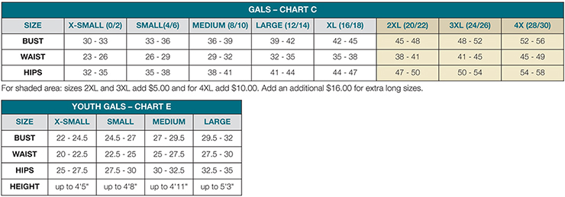
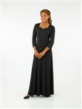Taylor Sweetheart Neckline
Style #120
Our Price: $60.00

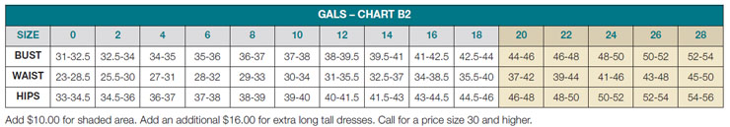

Laydown Collar Non-Pleated Dress Shirts BUY THIS ONLY IN BLACK
Style #M03
Our Price: $16.00
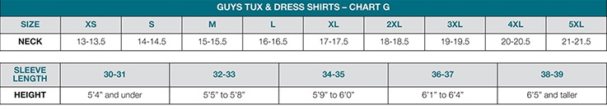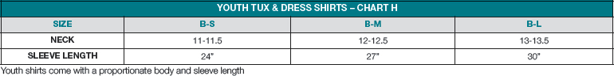

IF you do not already have solid black dress pants, similar to “suit” pants, here is an option for purchase….
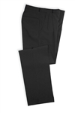Polyester Adjustable Elastic Waist Dress Trousers
Style #3024P
Our Price: $20.00
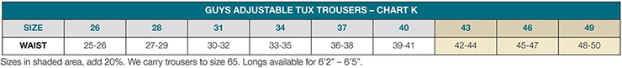

IF you have any questions or issues when ordering, please do not hesitate to contact me at BOTH email addresses this summer: sbenedict@springboro.org and smgbenedict@gmail.com

Thank you
Sarah Benedict

